Bahria University

Karachi Campus



LAB PROJECT DOCUMENT

**SUBMITTED BY:** Abdul Basit (02-131192-066)

Mirza Farooq Baig (02-131192- )

Sami ullah Khan (02-131192- 071)

**SUBMITTED TO: Sir Rehan Baig | COURSE: Computer Fundamentals Lab**

Microsoft Access:

HOSPITAL DATABASE

For **Patient Form** first we have created a table in which we entered the fields of ID, Patient Name, Father Name, Address, Appointment, Doctor Name & Patient history with their respected Data types. Then we went to the create tab and open a blank form in which we went to the design view. There from the design tab we selected the required number of text boxes for the fields in which we can enter data and named those text boxes to use them in the query. Then we have selected three buttons to save, delete and clear the record entered. Then from the same design tab we selected a Sub form and paste it on our original form. To do so it will appear a dialog box in which we select the table of patient to appear in the Sub form. In last to make the buttons working we write the following queries by going to the properties of these buttons, in the event option, we double click on the “on click” option then it will appear Microsoft Visual Basic application where we write the query of the button which we have selected.

*First Query: Save

*Second Query: Delete

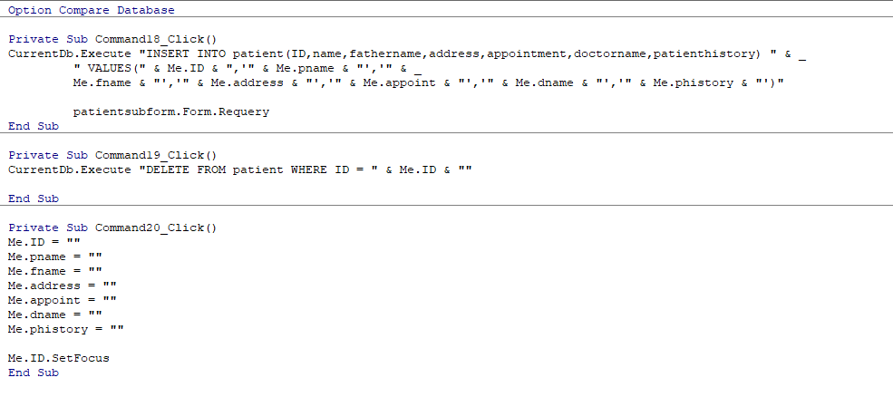*Third Query: Clear

After writing the queries the buttons starts working and we can enter the data into the form.

To create the **Patient’s Report** we go to the table of patient’s record then go to the create option in the ribbon and select the report option. It created the patients report and then we save it. We can customize the report also by going to the layout view.

Similarly for **Doctor Form** first we have created a table in which we entered the fields of ID, Doctor Name, Specialization, Fees and Phone Number with their respected Data types. Then we went to the create tab and open a blank form in which we went to the design view. There from the design tab we selected the required number of text boxes for the fields in which we can enter data and named those text boxes to use them in the query. Then we have selected three buttons to save, delete and clear the record entered. Then from the same design tab we selected a Sub form and paste it on our original form. To do so it will appear a dialog box in which we select the table of doctor to appear in the Sub form. In last to make the buttons working we write the following queries by going to the properties of these buttons, in the event option, we double click on the “on click” option then it will appear Microsoft Visual Basic application where we write the query of the button which we have selected.

*First Query: Save

*Second Query: Delete

*Third Query: Clear

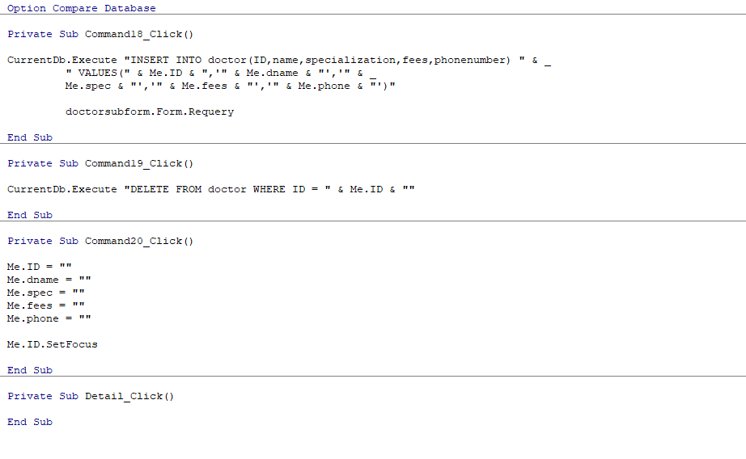

After writing the queries the buttons starts working and we can enter the data into the form.

To create **Doctor’s Monthly Income Report** first we have created a table in which we entered the fields of ID, Doctor Name, Fees, Number of patients per month and Monthly income (Same Doctor name and fees taken as entered in the above form) with their respected Data types. The last field that we have entered of Monthly income is a calculated field which we have selected in the data type option of this field. By selecting calculated data type it will appear a dialog box in which we entered the following expression:

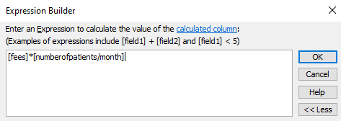

After creating and saving the table of Doctor’s monthly income we go to the create tab and select the report option. It automatically generated the report of Doctor’ monthly income. Then we saved the report. You can also customize the report by going to the design view of the report.

HTML:

Hospital Webpage

For creating a webpage we used bootstrap (version 4.4.1) which is the latest version, we have six different pages:

1. Home
2. Doctors
3. Departments
4. About us
5. Contact us
6. Login or sign up page

In these pages department is further divided into six sub departments, which includes:

* Department of heart
* Department of OPD
* Department of Dental
* Department of ENT
* Department of General surgery
* Department of Radiology

By using our online website a patient can find the doctor of the particular disease and also patient can see the timing of particular doctor on each day.